**ENHANCED SMART STICK FOR VISUALLY IMPAIRED**

**By**

**NWALA BLESSING UCHECHI (ANU13230240)**

**OLU VICTORIA OSEENY (ANU13230175)**

A report of the project

*Submitted to the*

**SCHOOL OF ENGINEERING**

For the partial fulfilment

Of the

*Award of the degree of*

**Bachelor of Engineering**

In

**Computer Engineering**



DEPARTMENT OF COMPUTER ENGINEERING

ALL NATIONS UNIVERSITY COLLEGE, KOFORIDUA.

FEBUARY 2017

**CERTIFICATE**

Certified that this report titled “**ENHANCED SMART STICK FOR VISUALLY IMPAIRED**” is a *bona fide* work of **Miss Nwala Uchechi Blessing (ANU13230240) and Miss Olu Oseeny Victoria (ANU13230175),** who carried out the work under my supervision, for the partial fulfilment of the requirements for the award of the degree of *Bachelor of Engineering* in *Computer Engineering*. Certified further that to the best of my knowledge and belief, the work reported herein does not form part of any other thesis or dissertation on the basis of which a degree or an award was conferred on an earlier occasion.

…………………………………. ……………………………………..

**ANU13230240 ANU13230175**

Place: Koforidua. Mr. Julius Jejeniwa

Supervisor,

Date: Dept. of Computer Engineering and Science,

All Nations University College,

Koforidua. .

**COUNTERSIGNED**

**EXTERNAL EXAMINER** **HEAD OF DEPARTMENT**

Department of Computer Engineering Department of Computer Engineering

KNUST ANUC

Kumasi. Koforidua

**ACKNOWLEDGEMENT**

Through this acknowledgment, we express our sincere gratitude to all those people who have been associated with this project and have us with it and made it a worthwhile experience.

Firstly, we thank the almighty God for His grace on our lives.

We express our sincere gratitude to our guide Mr Julius Jjejeniwa, Department of computer engineering, for his cordial support, exemplary guidance, monitoring and constant encouragement. Whenever we needed help he was there for us.

We would like to thank final year project committee and faculty members of their sincere judgement in carrying our work.

We would also like to thank Mr. Jeffery Ashiawho who helped us when there was difficulty.

Lastly, we are obliged to our colleagues and our parents for their valuable guidance and co-operation during the period of this task. Their blessing, help and guidance was a deep inspiration to us.

**ABSTRACT**

The risk of having an involuntary injury is generally greater in people with visual disabilities when compared to people with good eye sight. Currently visually impaired individuals use white canes and smart canes which have limited capacity for navigation. These canes were developed to help visually impaired person avoid obstacles and aid them in navigating easily but are not reliable and still have some limitations. The main aim of our project focuses on enhancing the existing system in terms of reliability, efficiency and performance. This system would include two ultrasonic sensors, and a water sensor which will help detect obstacles and puddles. These sensors are programmed to give the user a quick alert before obstacles are encountered. The device would assist the blind in walking through the right path so as to minimize injuries.

**LIST OF TABLES**

**TABLE NO. TITILE PAGE NO**

4.1 ULTRASONIC SENSING 29

4.2 WATER SENSING 30

**LIST OF FIGURES**

**FIGURE NO. TITLE PAGE NO.**

3.1 THE PROPOSED SMART STICK 12

3.2 BLOCK DIAGRAM 14

3.3 FLOW CHART 15

3.4 USE CASE DIAGRAM 16

3.5 PICTURE OF AN ULTRASONIC SENSOR 17

3.6 PICTURE OF A WATER SENSOR 19

3.7 PICTURE OF A VIBRATION MOTOR 19

3.8 ELECTRICAL SYMBOL OF A DIODE 19

3.9 ELECTRICAL SYMBOL OF A CAPACITOR 20

3.10 ELECTRICAL SYMBOL OF A RESISTOR 20

3.11 PICTURE OF RESISTOR 21

3.12 ELECTRICAL SYMBOL OF LED 21

3.13 PICTURE OF LED 21

3.14 PICTURE OF JUMPER WIRES 22

3.15 PICTURE OF ARBUIMO ATMEGA2560 BOARD 23

3.16 PICTURE OF ARDUINO IDR 24

3.17 CIRCUIT DIAGRAM 25

**TABLE OF CONTENT**

**CHAPTER NO TITLE PAGENO**

**ABSTRACT** IV

**LIST OF TABLES** V

**LIST OF FIGURES** VI

1. **INTRODUCTION** 1

1.1 VISUAL IMPAIRMENT 2

1.1.1SYMPTOMS OF VISUAL IMPAIRMENT 2

1.1.2CAUSES OF VISUAL IMPAIRMENT 3

1.2PROBLEM STATEMNT 5

1.3OBJECTIVE 5

1.4RLEVANCE 6

**2 LITERATURE REVIEW** 8

**3 SYSTEM DESIGN AND IMPLEMENTATION** 11

3.1 EXISTING SYSTEM 11

3.2PROPOSED SYSTEM 12

3.3BLOCK DIAGRAM 14

3.4FLOWCHART 15

3.5USECASE DIAGRAM 16

**3.6 REQUIEMENTS** 17

3.6.1HARDWARE REQUIREMENTS 17-23

3.6.2 SOFTWARE REQUIREMENTS 24

3.7 CIRCUIT DIAGRAM 25

**3.8 SCENARIOS** 26

3.8.1 ENHANCED SMART CANE 26

3.8.2 ULTRASONIC DETECTION 26

**3.9 COMMUNICATION SYSTEM** 27

3.9.1 ULTRASONIC COMMUNICATION SYSTEM 27

3.9.2 WATER COMMUNICATION SYSTEM 27

3.9.3 ALERT COMMUNICATION SYSTEM 27

1. **TESTING AND ANALYSIS** 28

4.1TESTING 28

4.1.1SYSTEM’S OVERALL TEST ACCURACY 28

4.1.2ULTRASONIC SENSOR 28

4.1.3WATER SENSOR 29

* 1. EVALUATION 29

4.3TEST CASES 29-30

**5 CONCLUSION** 31

5.1 LIMITATION 31

5.2 FUTURE SCOPE 31

5.3 CONCLUSION

**REFRENCES** 32

**APPENDICES** 35

**CHAPTER ONE**

**INTRODUCTION**

Over the years different devices have been developed to help the visually impaired in navigation. These devices include glasses, trolleys, smart walking sticks, etc. The functionality of these devices developed to assist the visually impaired are still limited and thus the users are still responsible for their own safety and their ability to physically detect objects. Based on recent technologies, our system focuses on improving the existing smart canes, by using sensors that are programmed to detect obstacles quickly and accurately.

It’s a challenge when people can’t rely on their eyes during navigation. Moving through an unknown environment becomes difficult; these people have to depend on individuals with good eye sight to aid them in navigation. Visually impaired persons develop their other sense organs e.g. sense of hearing and touch to help them in knowing what happens in their environment. Normally, visually impaired persons use a white cane also known as a traditional cane for mobility; this can help users in navigation and help detect obstacles. Another option that helps visually impaired persons during navigation and obstacle detection is the use of guide dogs. The guide dog is a trained dog; the dogs detect holes, complex situations, danger, etc. The relationship between the dog and its owner is an aid in navigating easily. The users receive feedback from the dogs’ bark, sound and also by the movement of the dog on the chain tied to the dog and held by the user, user feels the attitude of the dog and is able to detect the situation and give appropriate orders. But these guide dogs are very expensive and have limited life span.

According to the world health organisation in August 2014, there are 285 million people estimated to be visually impaired worldwide,39 million are blind , 246 have low vision, and 90% of the worlds visually impaired live in low-income setting,82% of these people living with blindness are aged50% and above[12]. The objective of the entire system is to produce a portable, efficient and reliable device to assist the visually impaired. Our device is developed with an ultrasonic sensor, water sensor, arduino mega board, vibrating motor and a battery.

* 1. VISUAL IMPAIRMENT

Visual impairment is an eye disorder; the word visual impairment is an eye disorder that ranges from the presence of good useable vision to low vision, to absence of sight also known as total blindness [13]. Visual impairment is an eye disorder that cannot be fully corrected by ordinary prescription lenses, drugs/supplement or surgery. Object appear blurry and are difficult to identify by visually impaired patients. Complete blindness is the inability to see anything at all [14]. An individual who cannot see 200feetaway is legally blind, he or she sees only 20 feet away.

1.1.1SYMPTOMS OF VISUAL IMPAIRMENT

1. Cloudy vision

* Inability to identify objects.
* Inability to identify colours.
* Seeing only shadows.

1. Poor night vision

* Inability to see an identify objects at night.
* Difficulty in navigating at night.

1. Tunnel vision

* Close minded thinking.
* Restricted field of vision.

## 1.1.2 CAUSES OF VISUAL IMPAIRMENT

The leading causes of visual impairment in the world includes; cataracts, trachoma, vitamin A deficiency, retinitis pigmentosa, blood loss due to injury, alcohol intoxication, hallucinogenic drugs, medications, concussion or stroke, chroideremia, retinal detachment, diabetes retinopathy snakebite, panic attack abut a few to mention [13].

1. GLAUCOMA: This is a condition in which the optic nerve in the human eye is damaged. The optic nerve carries visual information from the human eye to the human brain.
2. MACULA DEGENERATION: This is an eye disorder that destroys the part of the human eyes that enables you see clearly. This kind of eye disorder is normally found in older adults from 60 and above.
3. CATARACTS: This eye disorder causes cloudy vision. They are common in adults mostly.
4. RETINITIS PIGMENTOSA: This eye disorder is caused when there is damage in the retina of the human eye. It leads to blindness in rare cases.
5. SNAKE BITES: It also leads to visual impairment due to the presence of neurotoxin venom of a snake in the nervous system.
6. BLOOD LOSS: Rapid blood loss due to injury causes blur vision which can lead to visual impairment.
7. ALCOHOL INTOXICATION: Too much intake of alcohol and its presence in the human body results to blurry vision which may result to visual impairment.

People suffering from visual impairment would benefit from the use of enhanced smart cane. Visually impaired patients constantly face challenge during navigation when compared with individuals with good eye sight. Current Assistive technologies that aid navigation for visually impaired patients are quite expensive and cannot be afforded generally by visually impaired patients because they are generally low income earners. Indoor navigation becomes a difficult task for the visually impaired patients especially when left alone in their environment. Enhanced smart stick will help reduce such difficulty that will be experienced by the visually impaired patient, by detecting obstacles/puddles quickly before the user come in contact with it. Enhanced smart stick can contribute to increased safety and independence for the user.

The aim of our project is to establish a smart cane device for people with visual impairment, making life easier for them by using an ultrasonic sensor and water sensor.

The final system should have the following;

* 2 ultrasonic sensors.
* Water sensor
* Vibration motor.
  1. PROBLEM STATEMENT

Smart canes are designed generally in assisting visually impaired patients during navigation. The existing smart canes developed to aid the visually impaired patients have some limitations. They include unreliability, inefficiency, complexity and poor performance. Generally, users of these canes find device more distracting than helpful. The enhanced smart stick is an enhancement on the existing canes based on their limitations. Users of the enhanced smart stick stand to benefit from a new smarter device that will be more helpful in navigation and also ensure their safety in navigating around their environment by detecting obstacles and puddles.

* 1. OBJECTIVE

Visually impaired persons are been catered for by people with good eye sight. It’s a challenge when individuals cannot see, individuals with visual impairment face challenges during navigation such as walking up the staircase and walking down the staircase and navigating generally around their surroundings. Been visually impaired does not stop an individual from achieving his/her future goals. We still believe that those with visual impairment can navigate freely around their surrounding without assistance from people with good eyesight, and be part of the world without laying much emphasis on their condition. Our objectives include;

1. Analyzing on the existing system.
2. Identify limitations in existing system.
3. Designing a user friendly and simple smart cane to assist visually impaired patients.
4. Designing an accurate and efficient smart cane with the use of programmable sensors.

Hopefully, due the establishment of the proposed solution in the future, individuals with visual impairment will live as though they have no illness at all thereby rendering our objectives accomplished.

* 1. RELEVANCE

Our proposed system which is known as Enhanced Smart Stick is important for people with visual impairment in the following ways.

* AWARENESS: The proposed system is important to the visually impaired in this aspect, it enables them to be conscious of the environment they are in and also alert them if an obstacle or puddle is present.
* SIMPLICITY: The proposed system is designed to be simple and user-friendly. The proposed system is developed and integrated with less and appropriate components which are fixed firmly to the device by so doing ensuring and achieving simplicity of device and making it easy to understand and used by the visually impaired.
* ACCURACY: The proposed system alerts users on time with much vibration if an obstacle is too close and does not alert users if obstacle is far away to avoid distractions. Also, if puddles/water is much the vibration is more thereby users can avoid puddles by so doing danger can be avoided and minimized.

**CHAPTER TWO**

**LITERATURE REVIEW**

A.Nurulnadwan, A.M.Ariffin and S.Siti Mahfuzah[1] developed the assistive courseware for low vision learners to take care of the needs of low vision learners in learning activities. Generally low vision learners face numerous challenges in learning activities particularly in terms of information access, navigation and pleasure. Their main objective of study includes;

* Identifying the needs of low vision learners in learning
* Reviewing past literatures related to multimedia learning theory
* Creating a courseware to cater for the needs of low vision learners based on multimedia learning theory.

Three methods were used to achieve their objective they include pre-production, production and post-production based on the 13 principles of multimedia learning theory they include;

* Spatial contiguity: ability of students to learn better with combination of words and pictures on screen presented near rather than far from each other.
* Multimedia principle: students learn better from words and pictures rather than words.
* Temporal contiguity principle: students learn from combination of words and pictures presented simultaneously.
* Modality principle: students learn better from animation rather than animation and on- screen text.
* Redundancy principle: students learn better from animation and narration rather than narration, animation and on-screen text.
* Individual difference principle: design effects are stronger for low knowledge learners rather than for high knowledge learners and spatial learners.
* Signalling principle: student learn better when cues that highlight the organisation of essential material are added.
* Segmenting principle: students learn better when a multimedia lesson is presented in user spaced segments rather than continuous units.
* Pre-training principle: students learn more deeply when they receive pre-training in the names and characteristics of key components.
* Personalization principle: students learn better when words are in conventional style rather than in a formal style.
* Voice principle: students learn better when words in a multimedia message are spoken by friendly human voice rather than a machine voice.
* Image principle: students do not learn more when speaker’s image is on screen rather than not on screen.

The assistive courseware still has some limitations. The device wasn’t accurate and couldn’t meet up their objectives; low vision learners still experienced difficulty in using the courseware

Juan .R. Terven and Joaguin Saks [2] highlighted on the drawbacks of existing assistive technologies for visually impaired. Based on this they developed a computer vision based system for object detection, social interaction, orientation and print access. Their device was a vibratory belt along with a virtual white cane with combination of Smartphone and laser pointer to stimulate cane. Based on devices used for the system production, the computer vision based assistive technology is very expensive to purchase by visually impaired patients.

Muhammad Haziq Kamalidin [3] innovated a sonar assistive device to aid visually impaired in both indoor and outdoor environment. Their device was developed using an ultrasonic sensor to detect obstacles. Their device still have limitations such as delay in alerting the user on obstacles been approached and detection of far obstacles that distracts the users.

Nurulnadwan Aziz [4] developed a device to assist visually impaired based on multiple intelligence and adapting knowledge from spiral model in teaching and learning process. The assistive courseware is fully equipped with multimedia intelligence theory and the use of SECI in transferring knowledge between assistive courseware and visually impaired learners. Their device was difficult to understand and couldn’t be used efficiently by visually impaired patients.

Ulrich .I. and Borisstein[5] developed a guide cane to assist visually impaired patients using robot technology to detect objects in an environment. The mobile robot also known as the wheeled robot has some advantages such as simplicity and accuracy in detecting and avoiding dangerous obstacles. The use of robot technology makes their device generally unaffordable by the visually impaired patients.

Rachel Rizzo and Hunter MC Namara [6] developed a smart cane, their objective was to upgrade the traditional white cane. The device was built using an ultrasonic sensor, vibration motor for haptic feedback and an adjustable ergonomic handle in order to increase the comfort and ease of the cane. Their device was developed successfully but still has some limitations such as inaccuracy of distance measured by the ultrasonic sensor on objects and inability of users to distinguish vibration intensity thereby, users cannot distinguish between far and near objects.

Salem Ahmed Alghamdi[7] developed a context-aware navigational system to aid the blind in mobility. The device was developed using active radio frequency identification, quick response code and a 3D camera. It also includes features for error detection based on novel algorithm that are able to detect the wrong path from the first metre, location identification, voice recognition and path planning. This navigational aid still has some limitations despite its great features they include;

* Use of multiple devices, system doesn’t come in one package.
* Ability to recognize different background voices in crowd.

Based on computer vision and sensors Ram Tirlangi and.Ch. Ravisankar[8] developed an electronic aid using raspberry pi3, ultrasonic sensor, and smart cane and supervised machine learning techniques to assist the visually impaired in navigation. Multiple devices are needed for device to function hereby rendering device difficult to use by visually impaired patients. Also, with the use of supervised learning technique in their system to aid navigation for visually impaired patients, users will need assistances from people with good eyesight to still aid them in mobility.

VipulV. Nahar[9] developed a smart blind walking stick for visually impaired people. This device was innovated to ease and improve navigation for visually impaired people using advanced technology. There device detects obstacles and help user find stick if misplaced but this smart stick still has some limitations such as complexity and late alert if obstacle is detected.

Amjed S. Al-Fahoum and his colleagues [10] developed a smart infrared micro controller- based blind guidance system to assist both the blind and visually impaired people using an infrared sensor, ultrasonic sensor and a Pic microcontroller. Their device includes a wearable equipment which consist of head hat and a mini stick to aid the user navigate easily without assistance from people with good eyesight, also device can scan areas lift, right and front of the blind regardless of its height and depth. Their device could detect presence obstacles and light. But still have some limitations such as interference of infrared sensor with sunlight and inaccuracy of the infrared sensor. Also, device appears to be too noisy in residential and official environment due to the buzzer alert.

**CHAPTER THREE**

**SYSTEM DESIGN AND IMPLEMENTATION**

**3.**1 EXISTING SYSTEM

The Smart Blind Walking stick is a new and creative device designed for visually impaired people [9]. This device was developed by Vipul.V.Nahar and his colleagues. Based on challenges faced by visually impaired people, Vipul.V.Nahar and his colleagues created a device to help the visually impaired people navigate with ease using advanced technology. The smart blind walking stick was developed using ultrasonic sensor, moisture sensor, buzzer and a Pic microcontroller.

The Smart Blind Walking stick functions by sensing obstacles that are close to the stick. Once obstacles are sensed, data is passed to the microcontroller; the microcontroller processes the data and sends a signal to sound a buzzer. Also, it detects volumetric amount of water on soil using moisture sensor, and also uses a wireless base remote to assist user find stick if misplaced.

Although the technology and features used in the development of the smart blind walking stick is quite fantastic, visually impaired patients still face few challenges when using this device due to the problems that were not tackled during production of the device. Such problem includes; inaccuracy and poor performance of the device, complexity of device an also inability of the moisture sensor to detect puddles in other environment in which soil isn’t present. Also, the buzzer which serves as an alert system to users is quite distracting in external, residential and official environment. Due to the inaccuracy and poor performance of the device, user’s encounter obstacles before an alert is made i.e. obstacles will be too close to the user before the buzzer alert is made. The presence of the wireless remote is of advantage to the user to help locate stick if misplaced but has a disadvantage, due to the size of the remote, user may misplace wireless remote and find it difficult to find remote if misplaced also, user may find it difficult to operate wireless remote.

3.2 PROPOSED SYSTEM

The proposed system is a navigational system called Enhanced Smart Stick for the visually impaired [ESS4VI]. The benefit of this system is to assist visually impaired people detect obstacles and puddles and avoid them.

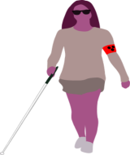

Enter building

Detect puddles

Detect objects

Avoid objects

Avoid puddles

**FIGURE 3.1: The proposed smart stick**

Based on the limitations on the existing system, our proposed system enables blind people to detect obstacles using ultrasonic sensors. If obstacle is close the main control circuit sends a signal to vibrate. It also helps the visually impaired to detect if puddles are in the environment with the help of the water sensor. The arduino microcontroller is powered by a battery to enable the flow of current in the system; obstacles are detected by the ultrasonic sensor and water sensor. These sensors send feedback to the microcontroller alerting it that an obstacle has been detected, the controller then sends signal to the vibration motor. The vibration motor vibrates and these vibration alert users. The proposed system is made of: sensor unit, alert system and power supply.

1. SENSOR UNIT

It uses an ultrasonic to detect any object that lies on the ground, situated at a distance of certain meters from the user. Ultrasound is reflected from a nearby object if any. The sensor detects the presence of any object that lies within the meter by detecting the reflected sound beam. The time interval at which the transmitter will transmit ultrasound depends on the walking speed of the user, for water indication electrodes are fitted at the bottom of the stick, these electrodes are sensing water and convey information to blind. The ultrasonic module consists of a transmitter and a receiver walking together [10].

1. ALERT SYSTEM

The alert system of the proposed system is the vibration motor. The vibration motor is a small device that is fixed to the handle of the walking stick it alerts the user if an obstacle or puddle is detected.

1. POWER SUPPLY

A 9v battery is used to power on the system and supply charges to the system in other for it to perform it function.

3**.**3 BLOCK DIAGRAM

The block diagram is used to clarify the overall concept without concerns with the details of implementation; it is made up of blocks connected by arrows that show the relationship between components of the system.

BATTERY

ARDUINO

MICROCONTROLLER

ULTRASONIC

SENSOR

VIBRATION

MOTOR

WATER

SENSOR

**Figure3.2 block diagram**

3.4 FLOW CHART

START

INITIALIZE HARDWARE

CHECK FOR WATER

CHECK FOR OBSTACLE

NO

IF WATER DETECTED

IF OBSTACLE DETECTED

NO

YES

YES

VIBRATE

VIBRATE

STOP

**Figure3.3 Obstacle and Water Detection**

3.5 USE CASE DIAGRAM

User

**Figure3.4Use Case Diagram**

**Fig3.5 obstacles range and stick response**

3.6 REQUIREMENTS

The enhanced smart stick is designed with a traditional stick with sensors integrated in it to make it smart. It consists of an Arduino ATmega board, sensors, vibration motor, resistors, capacitors and 9v battery. The ultrasonic sensor detect obstacles whereas, the water sensor detect puddles. Also a vibration motor integrated at the handle of the cane is used to alert the user if obstacle or puddle is detected and the overall system is powered using a 9v battery.

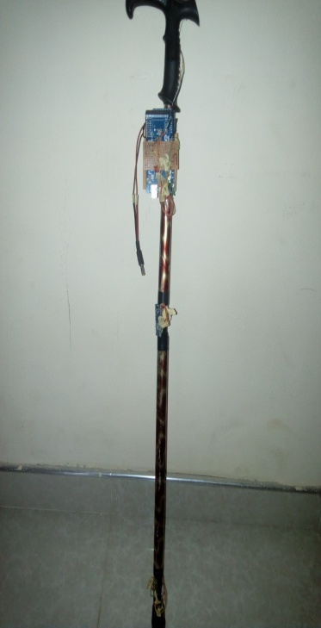

**Fig3.6.The Enhanced smart stick**

3.6.1HARDWARE REQUIREMENT

1). Ultrasonic sensor: Generates high frequency sound waves and evaluate the echo which is received back by the sensors. An ultrasonic is like an infrared where it will reflect on a surface in any shape, the ultrasonic has a better range than the infrared in robotic and automation industry, the ultrasonic is more accurate when compared with other sensors. Ultrasonic is suitable for developing the walking stick.

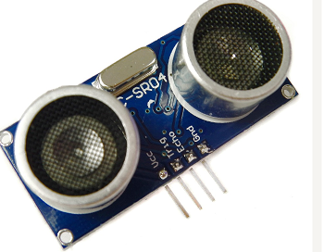

**Figure3.7 picture of an ultrasonic sensor**

The ultrasonic sensor is like the human pair of eyes, it comprises of 3components namely; transducer/receiver, comparator and detector unit, solid-state 0utput.

I). Transducer/ receiver: The transducer pulses send sounds wave outwards from the face of the sensor. The transducer also receives echoes of waves as reflected off an object. Transducers convert ultrasound waves to electrical signals and vice versa. They both transmit and receive and are called ultrasound transceivers, they are called transceivers because they both sense and transmit.

II). Comparator and detector: When the reflected echo is received by the sensor the comparator calculates distance by comparing received time frames to the speed of sound.

III). Solid- state output switching device: It generates electrical signals to be interpreted by an interface device like a programmable logic controller. The signal from the digital sensors indicates the presence or absence of an object in the sensing field. The signal from analogy sensors indicates the distance to an object in the sensing field.

ADVANTAGES OF AN ULTRASONIC SENSOR.

1). its response is not dependent upon the surface colour or optical reflectivity of the object..e.g. the sensing of a clear glass plate and white plastic plate is the same.

2). It functions with digital (on/off) outputs have excellent repeat sensing accuracy. It is possible to ignore immediate background objects, event at long sensing distance because switching hysteresis is relatively low.

3). Response of an analog ultrasonic sensor is linear with distance. By interfacing the sensor to an LED display. It is possible to have a visual indication target distance. This makes ultrasonic sensors ideal for level monitoring or linear motion monitoring applications.

2). Water sensor: It is a small electronic device that is designed to detect the presence of water. The water sensor can detect if water is over 0.5cm, the water sensor vibrator is stopped once it is taken out of the water.

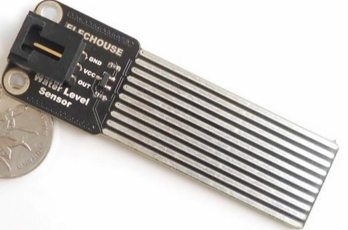

**Figure3.8 picture of a water sensor**

3). vibration motor: It is an electronic device or component in a dc power supplies for generating high voltage. It is used to alert the user of a device. Below is the general description of a vibrator motor;

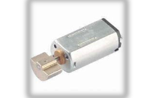

**Figure3.9 picture of a vibration motor**

4). Diodes: It’s a two terminal electrical component that conducts primarily in one direction( asymmetric conductance) it has low resistance to the flow of current in one direction and high resistance in the other. Diodes allow electric current to flow in one direction (called diode forward direction) while blocking **current** in the opposite direction (the reverse direction) current flows from left to right. Below is the electrical symbol of a diode;

+ _

**Figure3.10electrical symbol of diode**

5). Capacitors: A capacitor is passive 2 terminal electrical devices used to store electrical charge and are used in timer circuits. Capacitors and resistors work together to prevent false triggering of other components such as relays. It temporarily stores electrical energy in an electric field, and stores electrical energy when connected to its charging circuit. Below is the electrical representation of a capacitor.

Anode Cathode

**Figure3.11 electrical symbol of a capacitor**

6). Resistors: Resistors are electrical devices that limit or regulate the flow of electrical current in an electrical circuit. it is used to produce a special voltage for an active device such as a transistor. It is also used to reduce the flow of current, adjust signal level, divide voltages, bias active elements and terminate transmission among other users. Resistors are used to resist the flow of current and voltage flowing in a circuit. Ohms law is used to calculate resistance, this law states that the amount of current flowing through a conductor is directly proportional to the voltage across the points provide resistance is kept constant. Mathematical representation of the law; V=I*R V= voltage, I= current, R= resistance.

**Figure3.12electrical symbol of a resistor**

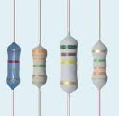

**Figure3.13 picture of resistors**

7). OPERATIONAL AMPLIFIER (OP-AMP): It is a DC coupled high gain electric voltage amplifier with different input and a single output. It is an amplifier with high input impedance used in circuits for performing mathematical operations on input voltage.

+v

Vin-

V out

Vin+

-v

**Figure3.14electrical symbol of Operational Amplifier**

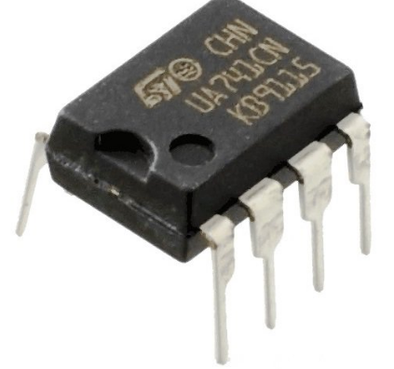

**Figure3.15 picture of Operational amplifier**

8**).** Jump wires: It’s an electrical wire or group of them in a cable with a connector or pin at each end which is normally used to interconnect the components of a bread board or other prototype or test circuit, internally or with other equipment or components without soldering.

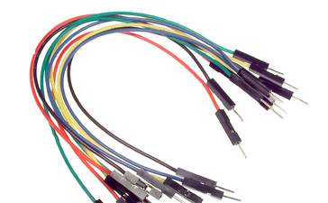

**Figure3.16 picture of jumper wires**

9) ARDUINO ATMEGA2560

Arduino boards are micro-controllers that consist of Atmel 8, 16, 32 bit AVR micro-controller specifically the ATMega 8, 168, 328, 1280 and2560. It is a small circuit board whichconsists of many electronic components. It provides sets of digital and analog I/O pins that can interface to various expansion boards and other circuits.

The Arduino board receives input from sensors, switches, relays, motors etc. The Arduino board connects to its IDE via USB port.

There are of many types. These may vary in size, use, the number of ports and processing speed. Examples of these types of Arduino hardware include **Arduino LeonardoArduino Nano, Arduino Mega, Arduino Mini, Arduino Galileo and Arduino UNO.** The Arduino name is a registered trademark, so it is not possible to name a cloned board Arduino. In this project, we made use of the ATMEGA2560 Arduino MEGA microcontroller.

Advantages**:**

* The software and hardware are free and open source, very flexible and easy to expand.
* It includes a variety of analog and digital ports, such as I2C, SPI serial interface.
* It is easy to use and connects to its IDE through a USB port.
* It is cheap and comes with free software and IDE environment.
* It is bundled with ready-to-use source code.

The Arduino Mega is a micro-controller board based on the ATMega2560. It has 54 digital I/O pins (of which 14 can be used as PWM outputs), 16 analog inputs, 4 UARTs (hardware serial ports), a USB connection, a power jack, a reset button and an ICSP header [10].

The Mega2560 also adds SDA and SCL pins next to the AREF. Also, it adds two new pins placed near the RESET pin. One is the IOREF that allows the shields to adapt to the voltage provided from the board. The other is reserved for future purposes.

Features:

* ATMega2560 micro-controller
* Input Voltage -7-12V
* 54 Digital I/O Pins(14 PWM outputs)
* 16 Analog Pins
* 256K Flash Memory
* 16Mhz clock speed

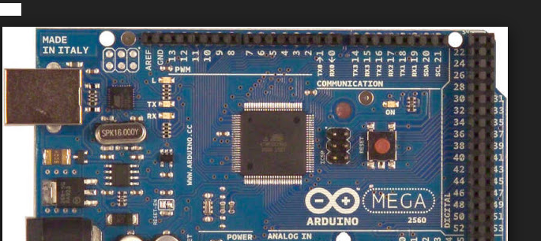

**Fig 3.17Picture of an Arduino ATmega2560 board**

* + 1. SOFTWARE REQUIREMENT

EMBEDDED C PROGRAMING LANGUAGE

The advanced smart cane is developed using embedded c programming language, it supports I/O operations. It includes a number of futures not available in normal c, such as, fixed point arithmetic, named address space, and basic I/O hardware addressing. It is small to learn, understand, program and debug, it is efficient. It combines functionality of high level languages and assemble languages.

COMPILER

An arduino compiler was used to convert high level language to object code. The arduino compiler is used to run the code in other to detect errors and correct the detected errors.



**Fig 3.18 Picture of an Arduino IDE**

* 1. CIRCUIT DIAGRAM

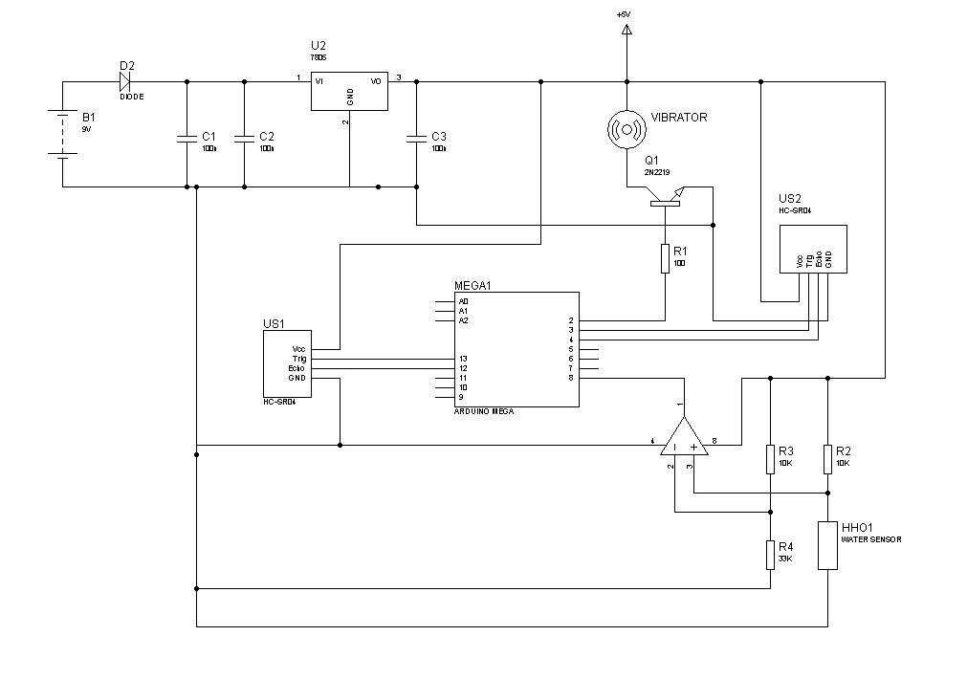**Figure3.19 Circuit diagram**

3.8 SCENARIOS

3.8.1 ENHANCED SMART STICK

The actor of this scenario is a visually impaired patient. The patient used the device to navigate around His environment, although it was difficult in navigating easily the first day of the scene. The second day patient became a little bit used to the device and was able to walk through the right part by avoiding obstacles detected. The enhanced smart stick works using two ultrasonic sensors placed in the stick at different positions, water sensor and a vibration motor.

The ultrasonic sensors help detect obstacles in front of the user. When an obstacle is detected, signal is sent to the microcontroller which then communicates with the vibration motor fixed at the handle of the smart cane and alerts the user on the presence of an obstacle by making vibrations. If the obstacle is close to the user the vibration made will be very intense and if obstacle is far away from the user vibration made will be less intense. Also, when the water sensor detect puddle, signal is sent to the microcontroller which then communicate with the vibration motor and vibration is made to alert the user. If puddle covers all the tracks in the water sensor vibration will be very intense and if puddles do not cover the entire track in the water sensor vibration made will be less intense.

The disadvantage to this is that although obstacles are detected user does not know the right path to take that leads to his/her destination. And also the user cannot distinguish the kind of liquid been detected. We couldn’t tackle this side of the problem due to time.

3.8.2. ULTRASONIC DETECTION

Visually impaired patients most at times would want to navigate around their environment independently. The system uses an ultrasonic sensor to detect obstacles in front of the user hereby, minimizing difficulties experienced by user during navigation. The system warns about obstacles the visually impaired patients would encounter.

The ultrasonic sensor is capable of detecting any obstacle that can fully or partially reflect sound Such as, metal, wood, stone, plastic, concrete, ceramic just but a few to mention. If an obstacle is detected by the ultrasonic sensor, it sends signal to the microcontroller which then broadcast the message and communicates with the user through the vibration motor.

3.8.3 WATER DETECTION

The water sensor is used to detect puddles encountered by visually impaired patients during navigation. The water sensor is capable of detecting shallow pool of water, and small pool of liquid. When puddles are detected, it sends information to the microcontroller which then communicates with the vibration motor to alert the user.

3.9. COMMUNICATION SYSTEM

Each device in the enhanced smart cane acts as a communication system because, signals are sent out and received by the microcontroller. Each device communicates with the microcontroller in other for the system to function properly.

3.9.1 ULTRASONIC COMMUNICATION SYSTEM

The ultrasonic sensor consists of a transceiver and receiver. The transceiver sends out signals and gets required data needed. Signals bounce back and are received through the receiver, the receiver communicates with the microcontroller with the Trig, which sends out ping for system to work while the Echo receives the ping being sent. The Trig and Echo pins are the communication lines that connect the ultrasonic sensor and arduino microcontroller.

3.9.2 WATER COMMUNICATION SYSTEM

The water sensor detects puddles and communicates to the arduino microcontroller. The operational amplifier is used in the device, it serves as a comparator to compare the regulation of voltage used in the water sensor unit and communicates with the arduino microcontroller.

3.9.3 ALERT COMMUNICATION SYSTEM.

Base on information received by the microcontroller from the ultrasonic sensors and water sensor the microcontroller communicates with the vibration motor which is the alert system in the smart cane. A transducer is being used which serves as a voltage divisor to regulate the vibrations made by the alert system. Depending on the distance of the obstacle and puddle different vibration is made.

**CHAPTER 4**

**TESTING AND ANALYSIS**

1. TESTING

All the hardware components were tested to check and ensure that they are functioning properly.

* 1. SYSTEM’S OVERALL TEST ACCURACY

Device was tested by bringing different obstacles with different shapes such as a plastic reading table, wooden chair and a ceramic water flask. Obstacles were placed at different distances; the result of the experiment was very good. It revealed accuracy of the system at 94% which indicates the efficiency and unique capability of the system in specifying the distance of obstacles encountered by the visually impaired patient.

* + 1. ULTRASONIC SENSOR

The ultrasonic sensors test worked perfectly. Various obstacles were presented in front of the ultrasonic sensor to test.

**Calibration**

void loop()

{

if(get_data_tick_counter >= 2) {

get_obstacle_data();

get_data_tick_counter = 0;

}

if(assessment_tick_counter >= 20) {

assess_obstacle_situation();

assessment_tick_counter = 0;

}

* + 1. WATER SENSOR

The water sensor worked perfectly. Water was presented and put on the water sensor to test if it functions properly. We put few drops of water which did not cover all the tracks in the water sensor, less vibration was made. Also, more water was added on the water sensor to cover all tracks, vibration became maximal.

**4.2**. EVALUATION

4.2.1 TEST CASES

Obstacle threshold distance=100

|  |  |  |
| --- | --- | --- |
| condition | status | Threshold  intensity |
| If far obstacle<100  but>=75 | Minimal vibration | Low |
| If near obstacle distance<=50 | Maximal  vibration | High |

**Table 4 .1 Ultrasonic Sensing**

|  |  |  |
| --- | --- | --- |
| condition | status | Threshold  Intensity |
| If water=50 | Maximal vibration | High |
| If water<50 | Minimal  vibration | Low |

**Table 4.2 Water sensing**

**CHAPTER 5**

**CONCLUSION**

5.1 LIMITATIONS

Due to time constraints, functions in the design of our system were limited to two features which are obstacles and puddles.

5.2 FUTURE SCOPE

Due to time, more features will be added to our device such as GPS to locate and give current position of the user. Also, a headset will be available with a voice recorder to aid communication. Lastly, the 9v battery will be replaced with a rechargeable battery and a small solar panel in other to power the device and serve user for a long period of time.

5.3CONCLUSION

This project was inspired first of all by the technology associated with navigation aid for visually impaired. We focused our attention on how to aid the visually impaired patients in navigating independently in their indoor environment. With our system, the visually impaired patients can continue his or her daily life activities around his/her environment. Even though our system was designed for visually impaired patients, it can also be used by other patients with disabilities such as the hearing impaired patients and also healthy people to aid them in navigation our objectives were met. Our system eliminates some of the challenges visually impaired patients encounter during navigation and also make them less dependent on individuals with good sight.

**REFERENCES**

[1] A. Nurulnadwan, A. M. Ariffin, and S. Siti Mahfuzah, "integrating multimedia learning theory in assistive courseware for low vision learners," *Jurnal Teknologi*, vol. 78, no. 2-2, Dec. 2015.

[2] Juan R.Terven, Joaguin Saks"New opportunities for computer vision-based Assistive technology systems for the visually impaired," *Computer*, vol. 47, no. 4, pp. 52–58, Apr. 2014.

[3] M. H. Kamaludin, N. H. Mahmood, A. H. Ahmad, C. Omar, and M. A. Md Yusof, "Sonar Assistive device for visually impaired people," *Jurnal Teknologi*, vol. 73, no. 6, Apr. 2015.

[4] Aziz, "Assistive Courseware for the visually impaired based on theory of multiple intelligence and SECI model," *American Journal of Economics and Business Administration*, vol. 3, no. 1, pp. 150–156, Jan. 2011.

[5] I. Ulrich and J. Borenstein, "The GuideCane-applying mobile robot technologies to assist the visually impaired," *IEEE Transactions on Systems, Man, and Cybernetics - Part A: Systems and Humans*, vol. 31, no. 2, pp. 131–136, Mar. 2012.

[6] Rachel rizzor, *smart cane*, amol pasarkar, Ed. [Online]. Available: soe.rutgers.edu/sites/default/files/imce/pdfs/gset-2014/Smart+Cane+Final. Accessed: Feb. 21, 2017.

[7]S.a Alghamdi, Ed., *context-aware navigational autonomy aid for the blind*. [Online]. Available: https://researchbank.rmit.edu.au/eserv/rmit:160981/Alghamdi.pdfby SA Alghamdi - ‎2014. Accessed: Feb. 21, 2017.

[8]Abshishek bhokere, *ultrasonic blind walking stick*, amruta amserkar, Ed. [Online]. Available: http://www.ijritcc.org/download/conferences/ICRTCEE.../1454314937_01-02-2016.pdfFeb1, 2016 - Ultrasonic Blind Walking Stick. Abhishek Bhokare, Amruta Amberkar Anvesh. Accessed: Feb. 21, 2017.

[9] R. Tirlangi, "Electronic travel aid for visually impaired people based on computer vision and sensor nodes using raspberry pi," *Indian Journal of Science and Technology*, vol. 9, no. 47,Jan.2017. [Online]. Available: http://www.indjst.org/index.php/indjst/article/view/106850. Accessed: Feb. 21, 2017.

[10] A. S. Al-Fahoum, *smart infrared microcontroller-based blind guidance system*, no. ID 726480, p. 7, Jun. 2013.

[11] "Cooling system temperature control using PIC Microcontroller," *International Journal of Science and Research (IJSR)*, vol. 5, no. 5, pp. 2157–2160, May 2016.

[12] [Online]. Available: http://WorldHealth Organization, “Visual Impairment and Blindness,” October 2013, http://www.who.int/mediacentre/factsheets/f s282/en/, (19 July 2014). Accessed: Jan. 26, 2017.

[13] S. E. Brodie, "M. Yanoff and J. S. Duker (eds): Ophthalmology," *Documenta Ophthalmologica*, vol. 129, no. 2, pp. 139–140, Jul. 2014.

[14]T. Lucassen and J. M. Schraagen, "Evaluating WikiTrust: A trust support tool for Wikipedia," *First Monday*, vol. 16, no. 5, Apr. 20

**APPENDICES**

ARDUINO CODE

#include <NewPing.h>

#include <TimerOne.h>

//#define DBG

#define ENTER_CRITICAL() asm("cli \n")

#define EXIT_CRITICAL() asm("sei \n")

#ifdef DBG

#define DIAGNOSTICS(x) x

#else

#define DIAGNOSTICS(x)

#endif

// input devices

#define MAX_DISTANCE 400 // Maximum distance we want to ping for (in centimeters). Maximum sensor distance is rated at 400-500cm.

#define TOP_SONAR_TRIGGER 4

#define TOP_SONAR_ECHO 6

#define BOTTOM_SONAR_TRIGGER 5

#define BOTTOM_SONAR_ECHO 7

#define WATER_SENSOR A0

NewPing top_sonar(TOP_SONAR_TRIGGER, TOP_SONAR_ECHO, MAX_DISTANCE); // NewPing setup of pins and maximum distance.

NewPing bottom_sonar(BOTTOM_SONAR_TRIGGER, BOTTOM_SONAR_ECHO, MAX_DISTANCE); // NewPing setup of pins and maximum distance.

// output devices

#define BUZZER 8

#define VIBRATOR 3

#define TURN_ON_BUZZER() digitalWrite(BUZZER, 1)

#define TURN_OFF_BUZZER() digitalWrite(BUZZER, 0)

#define TURN_ON_VIBRATOR() digitalWrite(VIBRATOR, 0)

#define TURN_OFF_VIBRATOR() digitalWrite(VIBRATOR, 1)

// trigger mechanism

#define TRG_SLOT_1 0

#define TRG_SLOT_2 1

#define TRG_SLOT_3 2

#define TRG_SLOT_4 3

#define TRG_SLOT_5 4

#define TRG_SLOT_6 5

#define TRG_LAST 6

#define TRG_MAX TRG_LAST

typedef uint8_t trg_time;

typedef void * trg_cb_data_p;

typedef void (*trg_callback) (trg_cb_data_p);

struct trg_desc {

trg_time ticks;

trg_callback cb;

trg_cb_data_p dp;

} triggers[TRG_MAX];

void trg_init(void);

void trg_inc_tmr(void);

uint8_t trg_check_callbacks(void);

uint8_t trg_install(uint8_t slot, uint8_t ticks, trg_callback cb, trg_cb_data_p dp);

void trg_init(void)

{

uint8_t i;

for(i = 0; i < TRG_MAX; i++) {

triggers[i].ticks = 0;

triggers[i].cb = NULL;

triggers[i].dp = NULL;

}

}

void trg_inc_tmr(void)

{

uint8_t i;

ENTER_CRITICAL();

for(i = 0; i < TRG_MAX; i++) {

if(triggers[i].ticks != 0) {

triggers[i].ticks--;

}

}

EXIT_CRITICAL();

while(trg_check_callbacks()) {

// do nothing

}

}

uint8_t trg_check_callbacks(void)

{

uint8_t i, cb_called = 0;

trg_callback cb = NULL;

trg_cb_data_p dp;

for(i = 0; i < TRG_MAX; i++) {

ENTER_CRITICAL();

if(triggers[i].ticks == 0 && triggers[i].cb != NULL) {

cb = triggers[i].cb;

dp = triggers[i].dp;

triggers[i].cb = NULL;

(*cb) (dp); // calling callback function

cb_called = 1;

}

EXIT_CRITICAL();

}

return cb_called;

}

uint8_t trg_install(uint8_t slot, uint8_t ticks, trg_callback cb, trg_cb_data_p dp)

{

ENTER_CRITICAL();

triggers[slot].ticks = ticks;

triggers[slot].cb = cb;

triggers[slot].dp = dp;

EXIT_CRITICAL();

return 1;

}

// trigger mechanism ends

// alert mechanism

#define ALERT_PERIOD 10

static bool alert_flag;

static uint8_t alert_on_period;

void alert(trg_cb_data_p dp)

{

trg_install(TRG_SLOT_4, 2, vibe_on, NULL);

trg_install(TRG_SLOT_5, 4, buzz_on, NULL);

}3

void buzz_on(trg_cb_data_p dp)

{

volatile uint16_t off_after = (alert_on_period * ALERT_PERIOD) / 100;

TURN_ON_BUZZER();

trg_install(TRG_SLOT_5, (uint8_t) off_after, buzz_off, NULL);

}

void buzz_off(trg_cb_data_p dp)

{

TURN_OFF_BUZZER();

if(alert_flag) {

volatile uint16_t on_after = ALERT_PERIOD - (alert_on_period*ALERT_PERIOD) / 100;

trg_install(TRG_SLOT_5, (uint8_t) on_after, buzz_on, NULL);

}

}

void vibe_on(trg_cb_data_p dp)

{

volatile uint16_t off_after = (alert_on_period * ALERT_PERIOD) / 100;

TURN_ON_VIBRATOR();

trg_install(TRG_SLOT_4, (uint8_t) off_after, vibe_off, NULL);

}

void vibe_off(trg_cb_data_p dp)

{

TURN_OFF_VIBRATOR();

if(alert_flag) {

volatile uint16_t on_after = ALERT_PERIOD - (alert_on_period*ALERT_PERIOD) / 100;

trg_install(TRG_SLOT_4, (uint8_t) on_after, vibe_on, NULL);

}

}

// alert mechanism ends

// obstacle detection mechanism

static uint16_t top_sonar_data;

static uint16_t bottom_sonar_data;

static uint8_t num_of_samples;

static uint8_t get_data_tick_counter;

static uint16_t water_level;

void get_obstacle_data()

{

uint16_t d;

num_of_samples++;

d = top_sonar.ping_cm();

//DIAGNOSTICS( Serial.print("Instantaneous top sensor data: "); )

//DIAGNOSTICS( Serial.print(d); )

//DIAGNOSTICS( Serial.println(" cm"); )

top_sonar_data += d;

d = bottom_sonar.ping_cm();

//DIAGNOSTICS( Serial.print("Instantaneous bottom sensor data: "); )

//DIAGNOSTICS( Serial.print(d); )

//DIAGNOSTICS( Serial.println(" cm"); )

bottom_sonar_data += d;

//water sensing

d = analogRead(WATER_SENSOR);

water_level += d;

}

#define OBSTACLE_THRESHOLD_DISTANCE 100

#define DISTANT_OBSTACLE_THRESHOLD_DISTANCE 75

#define NEAR_OBSTACLE_THRESHOLD_DISTANCE 50

#define WATER_LEVEL_THRESHOLD_A 50

#define WATER_LEVEL_THRESHOLD_B 500

uint8_t assessment_tick_counter;

void assess_obstacle_situation()

{

top_sonar_data /= num_of_samples;

bottom_sonar_data /= num_of_samples;

water_level /= num_of_samples;

DIAGNOSTICS( Serial.print("Mean top sensor data: "); )

DIAGNOSTICS( Serial.print(top_sonar_data); )

DIAGNOSTICS( Serial.println(" cm"); )

DIAGNOSTICS( Serial.print("Mean bottom sensor data: "); )

DIAGNOSTICS( Serial.print(bottom_sonar_data); )

DIAGNOSTICS( Serial.println(" cm"); )

DIAGNOSTICS( Serial.print("Water level reading: "); )

DIAGNOSTICS( Serial.print(water_level); )

if(top_sonar_data > OBSTACLE_THRESHOLD_DISTANCE &&

bottom_sonar_data > OBSTACLE_THRESHOLD_DISTANCE &&

water_level < WATER_LEVEL_THRESHOLD_A) {

alert_on_period = 0;

alert_flag = false;

}

else /*if(top_sonar_data > 0 || bottom_sonar_data > 0)*/ {

alert_flag = true;

if(top_sonar_data < NEAR_OBSTACLE_THRESHOLD_DISTANCE ||

bottom_sonar_data < NEAR_OBSTACLE_THRESHOLD_DISTANCE ||

water_level > WATER_LEVEL_THRESHOLD_B) {

alert_on_period = 50;

}

else {

alert_on_period = 10;

}

trg_install(TRG_SLOT_3, 0, alert, NULL);

}

num_of_samples = 0;

top_sonar_data = 0;

bottom_sonar_data = 0;

water_level = 0;

}

void setup()

{

DIAGNOSTICS( Serial.begin(9600); )

top_sonar_data = 0;

bottom_sonar_data = 0;

water_level = 0;

alert_flag = 0;

alert_on_period = 0;

num_of_samples = 0;

assessment_tick_counter = 0;

get_data_tick_counter = 0;

trg_init();

//trg_install(TRG_SLOT_1, 10, get_obstacle_data, NULL);

//trg_install(TRG_SLOT_2, 20, assess_obstacle_situation, NULL);

pinMode(BUZZER, OUTPUT);

pinMode(VIBRATOR, OUTPUT);

TURN_OFF_BUZZER();

TURN_OFF_VIBRATOR();

delay(2000);

TURN_ON_BUZZER();

delay(100);

TURN_OFF_BUZZER();

TURN_ON_VIBRATOR();

delay(100);

TURN_OFF_VIBRATOR();

Timer1.initialize(100000); // set a timer of length 100000 microseconds (or 0.1 sec, or 10Hz)

Timer1.attachInterrupt( timer1_isr ); // attach the service routine here

}

void loop()

{

if(get_data_tick_counter >= 2) {

get_obstacle_data();

get_data_tick_counter = 0;

}

if(assessment_tick_counter >= 20) {

assess_obstacle_situation();

assessment_tick_counter = 0;

}

}

/// --------------------------

/// Custom ISR Timer Routine

/// --------------------------

void timer1_isr()

{

assessment_tick_counter++;

get_data_tick_counter++;

trg_inc_tmr();

}